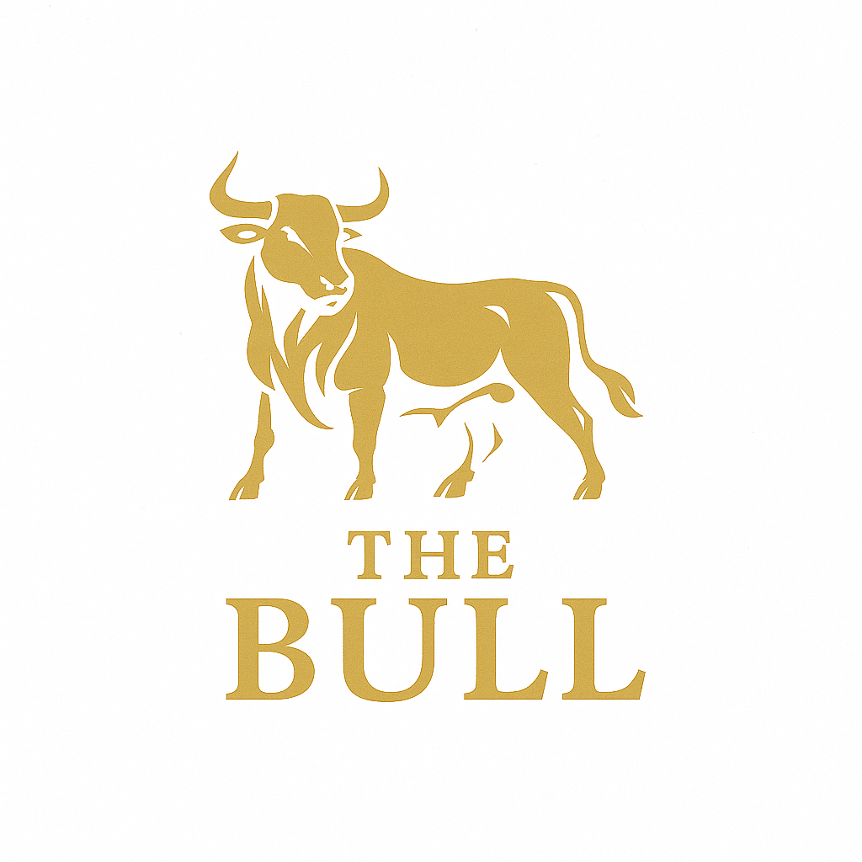
The Bull
Church Road, Corringham, Essex SS17 9AT
Tel: 01375 645000 • Email: info@bull-pub.co.uk

Christmas Menu Pre-Order Sheet

Reservation Name |  | Party Size
Date |  | Time
Contact Number |  | Email

Guest Name | Starter | Main | Dessert | Allergies / Notes

Menu Reference
Starters:
– Tomato & Basil Soup (With fresh bread and butter)
– Chicken Liver Pâté (Warm crusty breads, red onion marmalade)
– King Prawn & Crab Salad (Topped with a Marie Rose sauce)
– Deep-Fried Brie Wedges (With cranberry & red onion chutney)
Mains:
– Festive Turkey Crown Roast (Smoked bacon pigs in blankets, roast potatoes, pork sage & onion stuffing, gravy)
– Roast Leg of Lamb (Pork sage & onion stuffing, Yorkshire pudding, roast potatoes, gravy)
– Roast Chicken Breast (Chasseur sauce, roast potatoes)
– Grilled Seabass Fillets (Crushed herby potatoes and a prawn & garlic butter)
– Vegetable & Goats Cheese En-Croûte (Roasted vegetables, goats cheese in puff pastry, tomato garlic sauce, roast potatoes)
Desserts:
– Individual Christmas Pudding (Brandy mascarpone cream)
– Apple & Cinnamon Crumble (Served with custard)
– Strawberry & White Chocolate Mousse (With shortbread biscuit)
– Lemon Curd Cheesecake (With vanilla ice cream)
– Festive Cheese Board (With crackers & chutney (£3 supplement))

Booking & Pre-Order Terms
• £5.00 per person deposit required to secure booking.
• 48-hour cancellation policy.
• Service charge will be added to tables of 6 people and over.

